**MSBA 250 — Applied Business Analytics**

**University of the Pacific**

**Spring 2024**

**Assignment 3**

**Due: Thursday, March 21, 2024**

**Instructions:**

This problem set has 5 questions. The full credit is 20.

**Problem 1 (3 points):**

Students in the new MBA class at a state university have the following specialization profile: Finance (83), Marketing (20), Operations (62), and Information systems (59). Find the probability that a student is either a finance or a marketing major.

Total = 83 + 20 + 62 + 59 = 224

Probability that a student is either a finance or a marketing major:

P (finance | marketing)

**Problem 2 (6 points):**

The weekly demand of a slow-moving product has the following probability mass function:

|  |  |
| --- | --- |
| Demand, *x* | Probability, *f(x)* |
| 0 | 0.2 |
| 1 | 0.4 |
| 2 | 0.3 |
| 3 | 0.1 |
| 4 or more | 0 |

1. Find the expected value of weekly demand (2 points)

E[X] = x*f(x) = 0*0.2 + 1*0.4 + 2*0.3 + 4*0 = 1.3

1. Find the variance of weekly demand (2 points)

(x - E[X])2 * f(x)

Var[X] = (0-1.3)2 * 0.2 + (1-1.3)2 * 0.4 + (2-1.3)2 * 0.3 + (3-1.3)2 * 0.1 + (4-1.3)2 * 0 = 0.81

1. Find the standard deviation of weekly demand (2 points)

**Problem 3 (5 points):**

The distribution of SAT scores in math for an incoming class of business students has a mean of 610 and standard deviation of 30. Assume that the scores are normally distributed.

1. Find the probability that an individual’s SAT score is greater than 600. (3 points)

=> area = 0.37070

P (x > 600) = 1 - 0.37070 = 0.6293

1. Please list the function(s) you use in EXCEL in solving this problem. (2 points)

P(x>600) = 1 - NORM.DIST(600, 610, 30, TRUE)

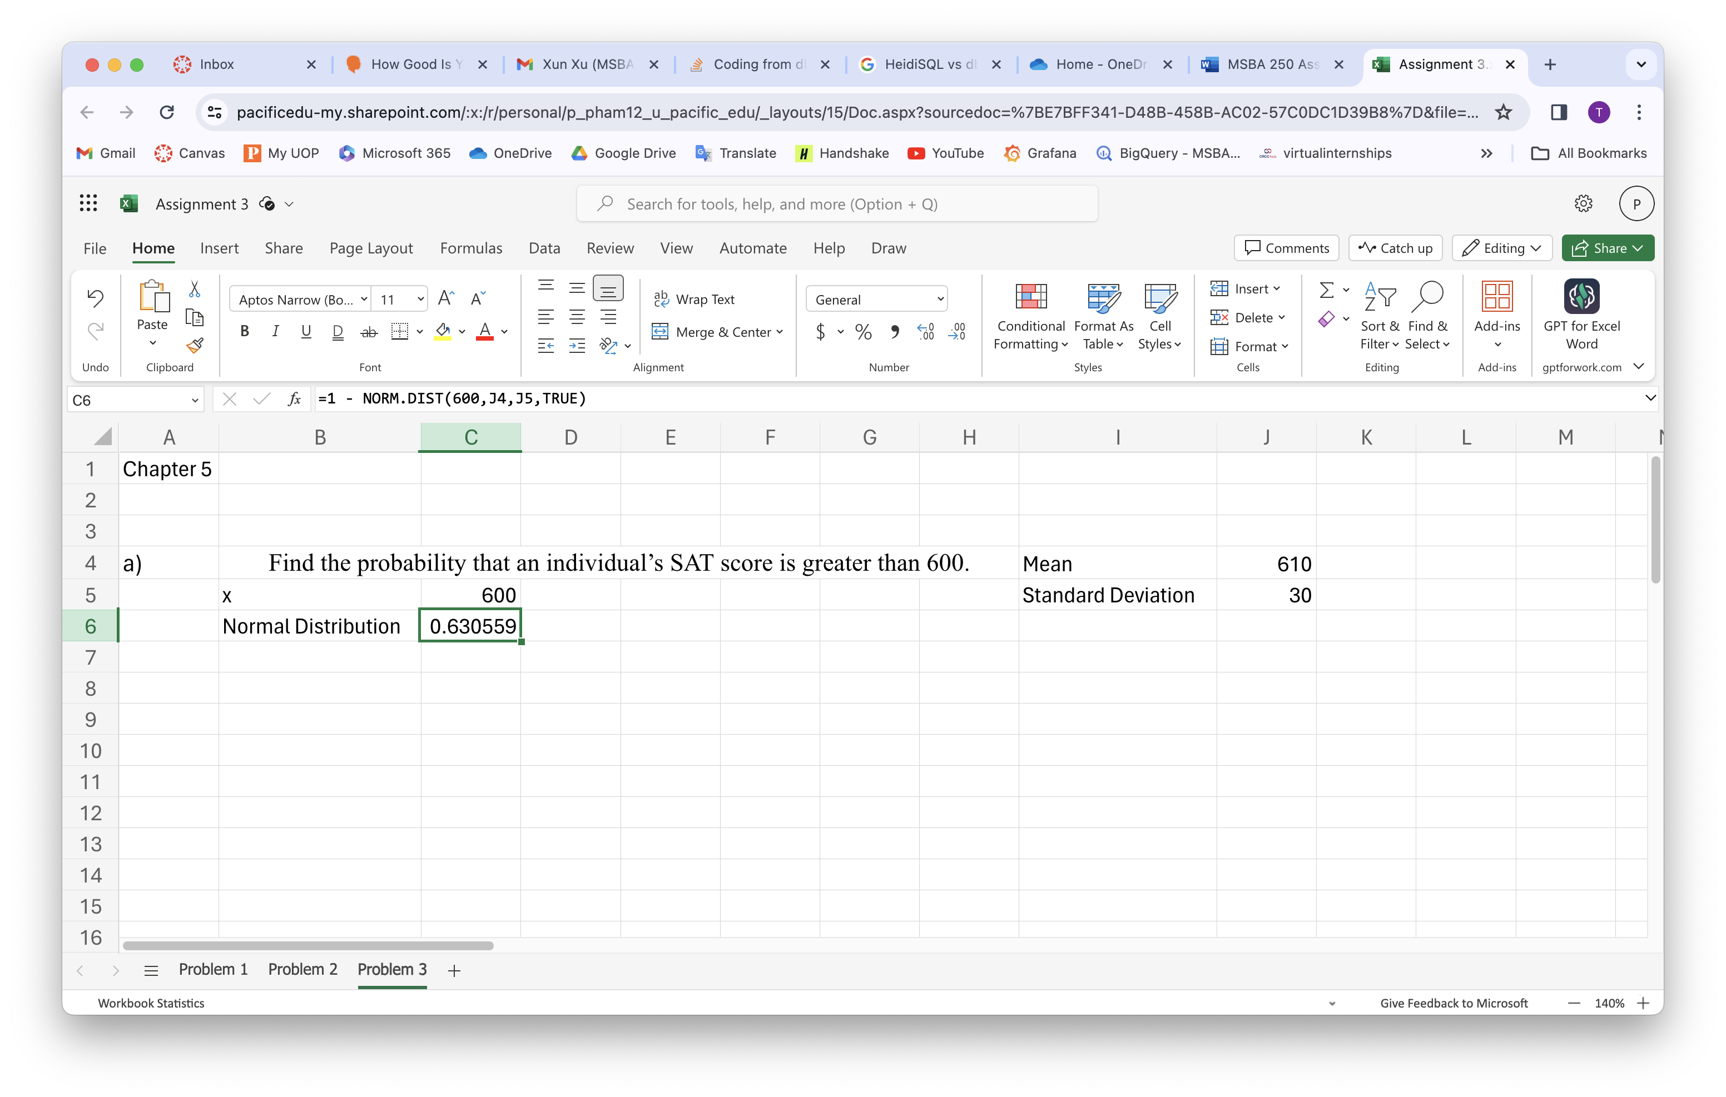

**Problem 4 (2 points):**

This problem is about the Tableau application of a function. Please review the functions on the right side of the function box of Tableau. Please find the EXCEL file named “petroleum.” Please calculate the correlation between 2019 and 2020 petroleum emission.

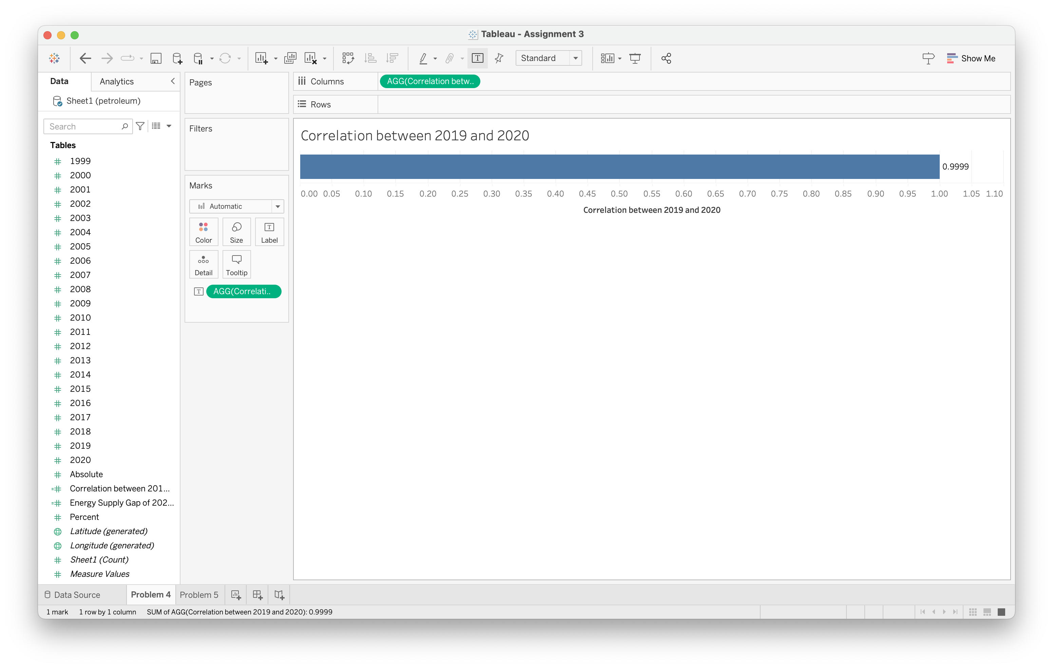

**Problem 5 (4 points):**

This problem is about the Tableau application of a function. Please find the EXCEL file named “petroleum.” Please create a variable (column) to reflect the gap between energy supply of 2020 and 2000 (by using the number of 2020 – 2000) for each state. Then please visualize the petroleum emission for 2000, 2020, and the gap of each state by a graph. The graph can be a bar graph or other graphs. Please attach a screenshot of the graph. Please discuss the insights based on the graph.

Based on the graph, between 2000 and 2020, the state with the highest energy emission is California, -58.32, while Texas has the lowest energy emission, 6.28. Moreover, there are only over 10 states that have positive energy supply between 2020 and 2000. 